CONTENTS
1.PREFACE 3
1.1 BASIC INTRODUCTION 3
1.2 NOTICE 4
2. PARAMETERS 5
3.MACHINE WORKING PRINCIPLE 5
4.MACHINE STRUCTURE 5
4.1 MAIN STRUCTURE 6
4.1.1 2nd Generation 0.5L hopper 4 heads linear weigher（JW-AX4-2-1） 6
4.1.2 2nd Generation 3L hopper 4 heads linear weigher（JW-AX4-2-2） 6
4.1.3 2nd Generation 15L hopper 2 heads linear weigher（JW-AX2-2-1） 7
4.1.4 2nd Generation 4.5L hopper 2 heads linear weigher（JW-AX2-2-2） 8
4.1.5 2nd Generation one head linear weigher（JW-AX1-2-1） 9
4.2 EXTERNAL SPECIFICATION 10
4.2.1 2nd Generation 0.5L hopper 4 heads linear weigher（JW-AX4-2-1） 10
4.2.2 2nd Generation 3L hopper 4 heads linear weigher（JW-AX4-2-2） 12
4.2.3 2nd Generation 15L hopper 2 heads linear weigher（JW-AX2-2-1） 14
4.2.4 2nd Generation 4.5L hopper 2 heads linear weigher（JW-AX2-2-2） 16
4.2.5 2nd Generation one head linear weigher（JW-AX1-2-1） 18
4.3 COMMON PARTS INSTALLATION 20
4.3.1 WEIGH HOPPER INSTALLATION 20
4.3.2 LINEAR VIBRATION PAN INSTALLATION 21
5.DAILY OPERATION 22
5.1 USER LOGGING 22
5.2 MAIN INTERFACE 23
5.3RUNNING 25
5.3.1 RUNNING INTERFACE 25
5.3.2 OPERATION CONTROL 27
5.4 PRODUCTION STATISTICS 28
5.4.1 PRODUCTION RECORD 28
5.4.2 HISTOGRAM 30
5.4.3 ALARM RECORD 31
5.5 MANAUL TEST 32
5.5.1 MANAUL TEST INTERFACE 33
5.5.2 AMPLITUDE AUTO ADJUST 34
5.6 PROGRAM SETUP 35
5.6.1 PROGRAM SETUP1 35
5.6.2 PROGRAM SETTING 2 41
5.7 SYSTEM SETUP 43
5.7.1 SYSTEM SETUP INTERFACE 43
5.7.2 SYSTEM MANAGERMENT 46
5.7.3 MOTOR SETUP 47
5.7.4 MODULE INFO 49
5.8 SENSOR CALIBRATION 50
6. MAINTENANCE AND REPAIR 52
6.1 MAINTENANCE 52
6.2 REPAIR 53
6.3 FAULT DIAGNOSIS 53
7. TRANSPORTATION & STORAGE 54
8. OPEN AND CHECK 55
9. ELECTRIC CIRCUIT DIAGRAM 55

1.PREFACE
Thank you for using JW-AX Series 2nd Generation Linear Weighers.
This manual is to help users use and maintain the machine, the following are the details of regular usage and basic maintain methods.

1.1 BASIC INTRODUCTION
- This machine through controlling speed of feeding according to weighing feedback,approaching the target weight.
- This machine is particularly suitable for weighing small granular products.
- The machine uses CAN bus communication mode, the weighing process of each weighing hopper is carried out by independent module board, which costs less communication time with the motherboard, makes the feedback of weight information and the process of vibrator amplitude more quickly.
- The machine works stable with high speed and high accruracy.

1.2 NOTICE
- Please read this manual carefully before using the machine.
- Environment requirements：
  - Temperature：0 ～ 40°C;
  - Humidity：35-85%;
  - Power：AC 220±10%V, 50/60Hz;
  - Installation place：horizontal and no vibration surface;
  - Earth line：Make sure the machine is connected to the earth;
  - Keep away from interference and shield;
  - For food packaging the machine runs must be with sterile and non-dust environment..
- No bumping or strong pressure on weigh hoppers.
- Check and empty the rest products inside the machine before running.
- Press “ZERO”to make empty and zeroing before the first running.
- Turn off the power before repairing and cleaning the machine.
- When electronic part is failed, Non-electronic engineer is prohibited to repair the machine.
- Be careful when cleaning and repairing the machine, since there is a certain distance from the ground when the weigher is installed above the packaging machine.
- The DC voltage for the connection signals with other equipments (such as packaging machine, conveyor, etc.) should be no more than 24V, the load current is no more than 100mA.
- It is prohibited to touch the hopper while the machine is running.
- When using the air compressor, air pressure must be stable, not less than 0.5MPa, and use dryer to keep dry for the cylinder.

2. PARAMETERS
Item No.  Parameters | JW-AX4-2-1 | JW-AX4-2-2 | JW-AX2-2-2 | JW-AX1-2-1
Power frequency(Hz) | 50/60 | 50/60 | 50/60 | 50/60
Required current (A) | 5 | 5 | 4 | 2.5
Power (W) | 1000 | 1000 | 800 | 500
Weigh head QTY. | 4 | 4 | 2 | 1
Single weighing range (g) | 10-400 | 10-2000 | 50-3000 | 50-3000
Hopper Volume (ml) | 500 | 3000 | 4500 | 4500
Max.weighing Speed | 70PPM/min | 50PPM/min | 32PPM/min | 20PPM/min
Preset program QTY | 20 | 20 | 20 | 20
Machine Size L(mm) | 684 | 885 | 685 | 792
Machine Size W(mm) | 684 | 800 | 814 | 470
Machine Size H(mm) | 738 | 1049 | 971 | 1006
Machine Weight (kg) | 140 | 160 | 130 | 60

3.MACHINE WORKING PRINCIPLE
Machine collects the real time from weight of the weigh hopper through the material, After analysis and processing, change the working vibrator amplitude to control the speed of feeding and make the weight of weigh hopper approach the target weight.

4.MACHINE STRUCTURE

4.1 MAIN STRUCTURE

4.1.1 2nd Generation 0.5L hopper 4 heads linear weigher（JW-AX4-2-1）

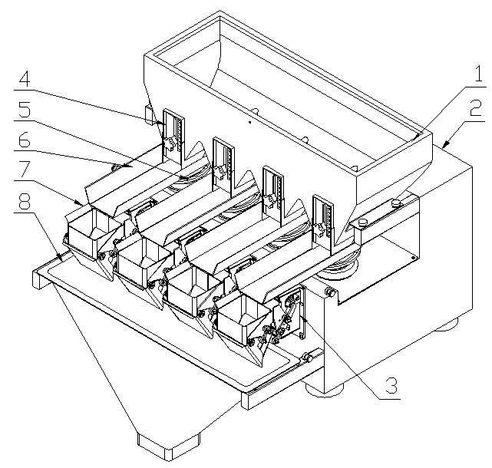

Chart 4.1.1.1

No. | Description | No. | Description
1 | Upper Storage Funnel | 5 | Stable Linear Vibrator
2 | Machine Frame | 6 | Linear Vibrator Pan
3 | 3 Kg Actuator | 7 | 0.5L Weigh Hopper
4 | Outlet Adjustable Plate | 8 | Discharge Chute Gate

4.1.2 2nd Generation 3L hopper 4 heads linear weigher（JW-AX4-2-2）

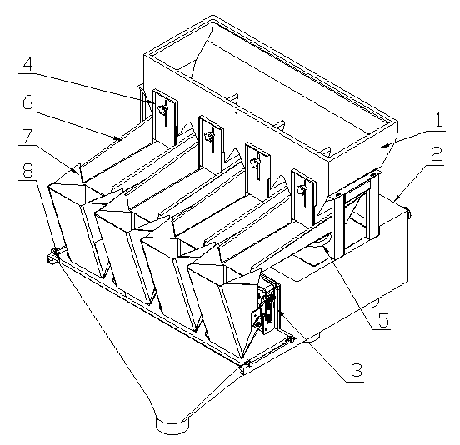

Chart 4.1.2.1

No. | Description | No. | Description
1 | Upper Storage Funnel | 5 | Stable Linear Vibrator
2 | Machine Frame | 6 | Linear Vibrator Pan
3 | 8 Kg Actuator | 7 | 3L Weigh Hopper
4 | Outlet Adjustable Plate | 8 | Discharge Chute Gate

4.1.3 2nd Generation 15L hopper 2 heads linear weigher（JW-AX2-2-1）

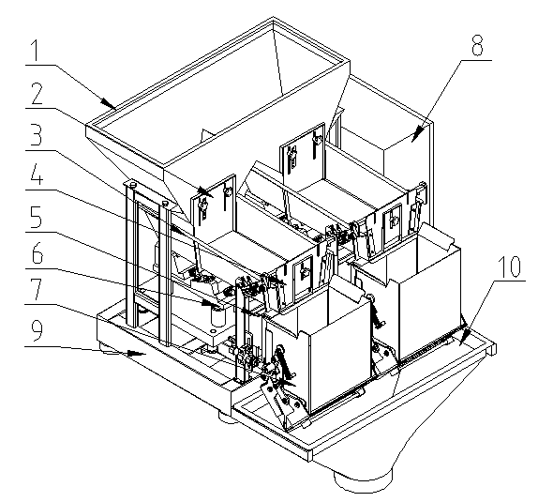

Chart 4.1.3.1

No. | Description | No. | Description
1 | Upper Storage Funnel | 6 | Big Linear Vibrator
2 | Outlet Adjustable Plate | 7 | Linear Vibrator Pan
3 | Linear Vibrator Pan | 8 | 17L Weigh Hopper
4 | Linear Vibrator Pan Back gauge | 9 | Base
5 | Weighing Part（40kg） | 10 | Discharge Chute Gate

4.1.4 2nd Generation 4.5L hopper 2 heads linear weigher（JW-AX2-2-2）

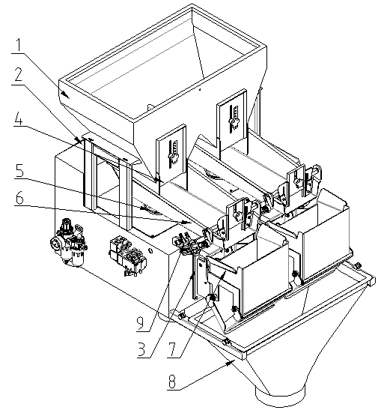
Chart 4.1.4.1

No. | Description | No. | Description
1 | Upper storage funnel | 6 | Linear vibrator pan
2 | Machine case | 7 | 4.5L weigh hopper
3 | 8KG Actuator | 8 | Discharge chute gate
4 | Outlet Adjustable Plate | 9 | Vibrator gate part
5 | Stability linear vibrator

4.1.5 2nd Generation one head linear weigher（JW-AX1-2-1）

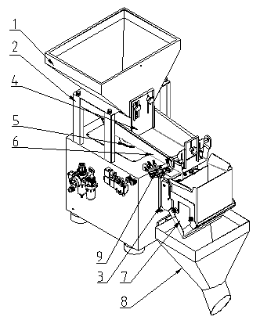
Chart 4.1.5.1

No. | Description | No. | Description
1 | Upper storage funnel | 6 | Linear vibrator pan
2 | Machine case | 7 | 4.5L weigh hopper
3 | 8KG Actuator | 8 | Discharge chute gate
4 | Outlet Adjustable Plate | 9 | Vibrator gate part
5 | Stability linear vibrator

4.2 EXTERNAL SPECIFICATION

4.2.1 2nd Generation 0.5L hopper 4 heads linear weigher（JW-AX4-2-1）
1.Packing Crate Size：684（L）×684 （W）×738（H）
2.Packing Weight：140Kg
3.Machine Size：as shown in Chart 4.2.1.1，Chart 4.2.1.2

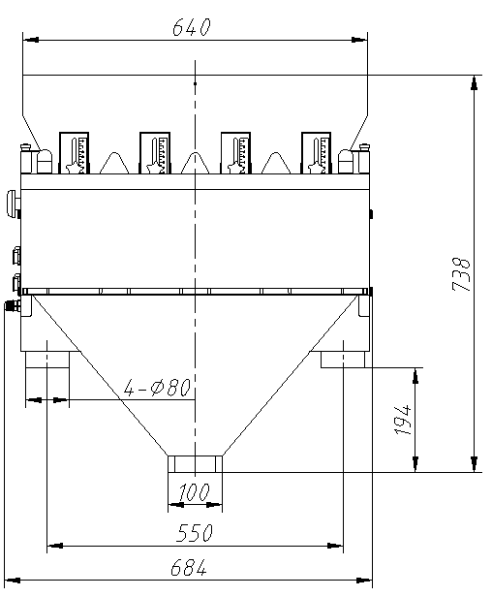

Chart 4.2.1.1

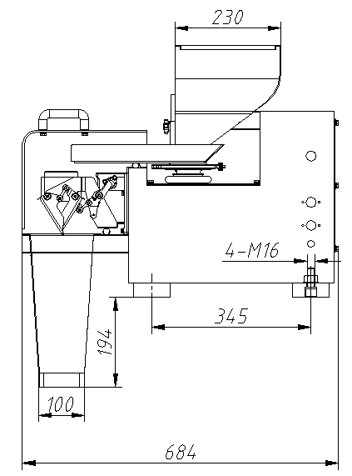

Chart 4.2.1.2

4.2.2 2nd Generation 3L hopper 4 heads linear weigher（JW-AX4-2-2）
1.Packing Crate Size：885（L）×800 （W）×1049（H）
2.Packing Weight：160Kg
3.Machine Size：as shown in Chart 4.2.2.1,Chart 4.2.2.2

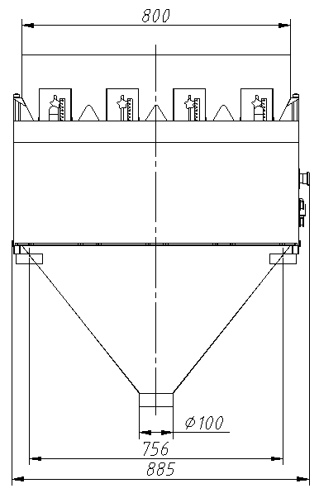

Chart 4.2.2.1

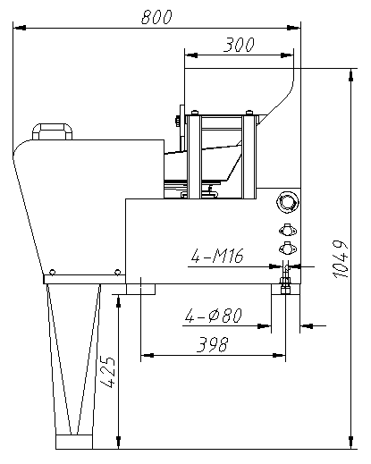

Chart 4.2.2.2

4.2.3 2nd Generation 15L hopper 2 heads linear weigher（JW-AX2-2-1）
1.Packing Crate Size：1053（L）×1063 （W）×1160（H）
2.Packing Weight：240Kg
3.Machine Size：as shown in Chart 4.2.3.1,Chart 4.2.3.2

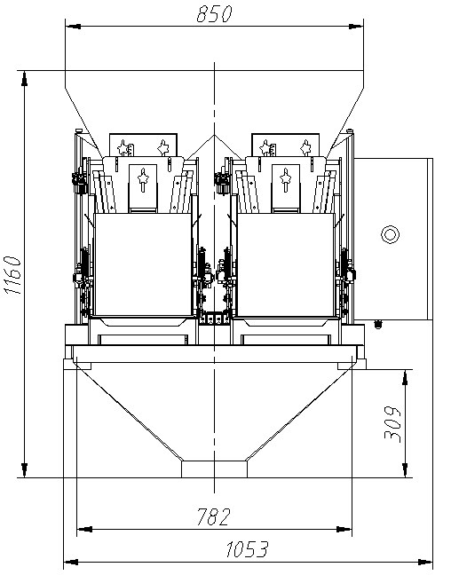

Chart 4.2.3.1

.

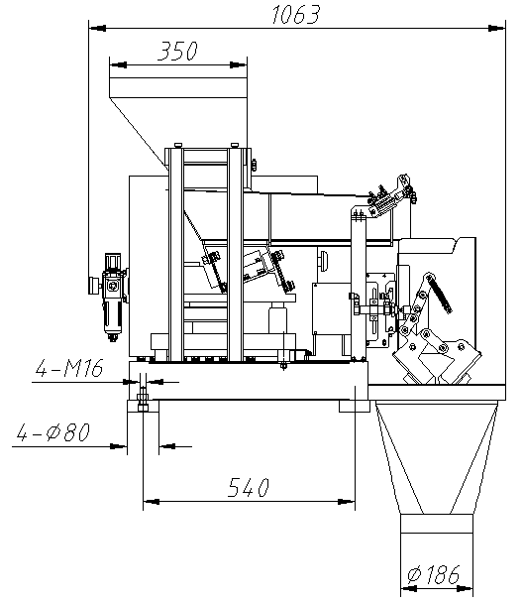

Chart 4.2.3.2

4.2.4 2nd Generation 4.5L hopper 2 heads linear weigher（JW-AX2-2-2）
1.Packing Crate Size：685（L）×814 （W）×971（H）
2.Packing Weight：130Kg
3.Machine Size：as shown in Chart 4.2.4.1,Chart 4.2.4.2

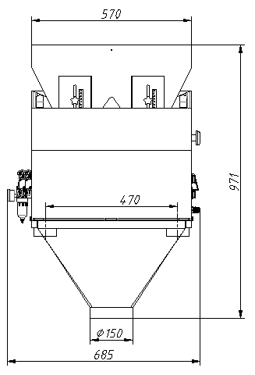

Chart 4.2.4.1

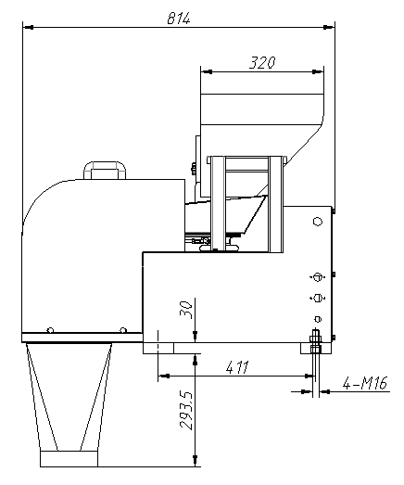

Chart 4.2.4.2

4.2.5 2nd Generation one head linear weigher（JW-AX1-2-1）
1.Packing Crate Size：792（L）×470（W）×1006（H）
2.Packing Weight：60Kg
3.Machine Size：as shown in Chart 4.2.5.1,Chart 4.2.5.2

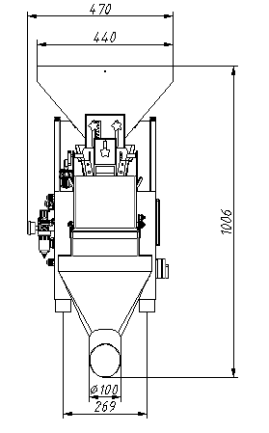
Chart 4.2.5.1

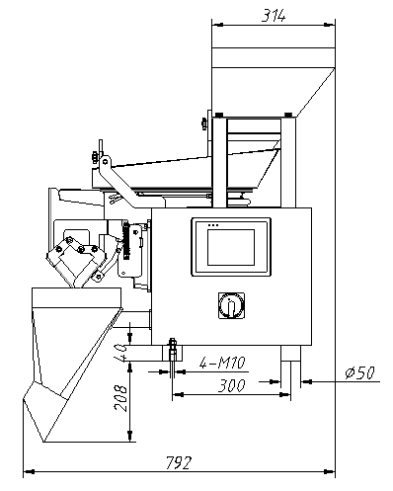
Chart 4.2.5.2

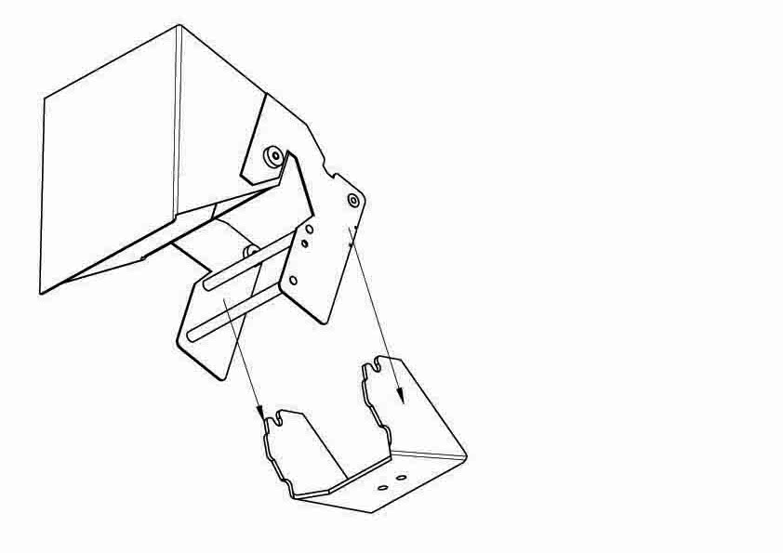
4.3 COMMON PARTS INSTALLATION

4.3.1 WEIGH HOPPER INSTALLATION
1.As shown in Chart 4.3.1.1,hold the hopper outer edge with right hand , gently input the fixed pole to the ‘U’ shape slot of the lower actuator axis.

Chart 4.3.1.1
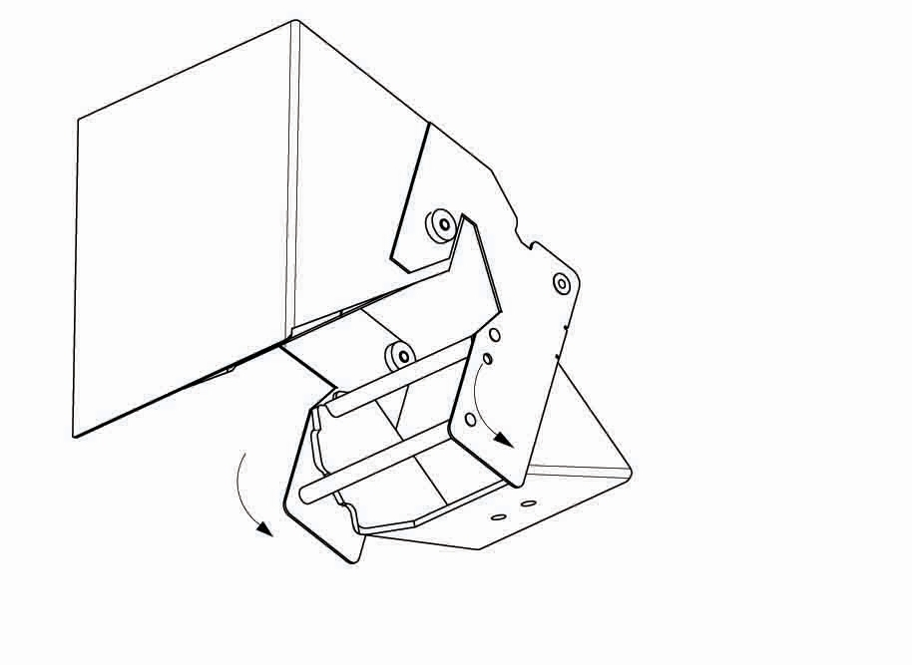

2.As shown in the chart 4.3.1.2,in the center of fixed pole, downward rotation, make the hopper is horizontal.

Chart 4.3.1.2

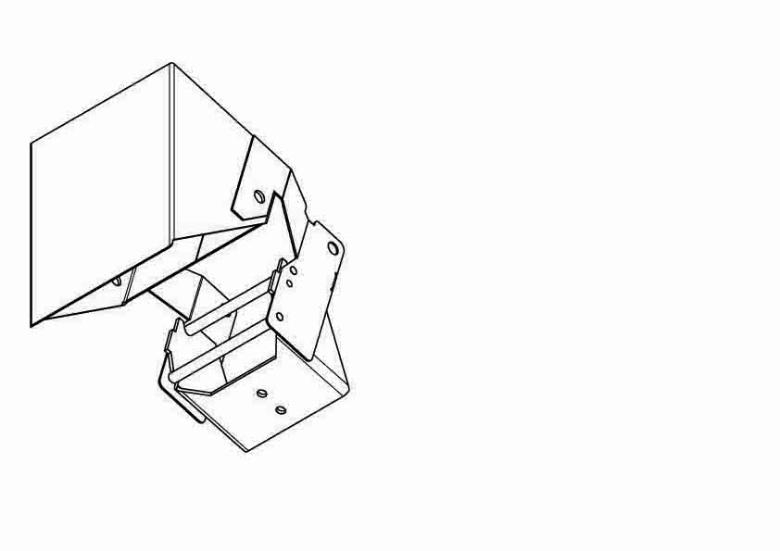
3.As shown in the chart 4.3.1.3, make sure the hoppers
don’t touch with actuator or vibration pan.

Chart 4.3.1.3

4.3.2 LINEAR VIBRATION PAN INSTALLATION
Waterproof vibration pan: As shown in Chart 4.3.2.1, loosen the locking handle, slantly insert section “a” of the Feeder Pan to section “b” of the Vibrator,make the Feeder Pan horizontal and tighten the locking handle.
NOTICE: Each Linear Feeder Pan should be well installed without bumping with each other.

Chart 4.3.2.1

5.DAILY OPERATION
The following is in the example of 2nd generation 0.5L hopper 4 heads linear wiegher to explain the daily operation.The difference of display for other model machines is hopper QTY,other parameters are the same.

5.1 USER LOGGING
Turn on the machine and automatically enter login interface.As below shows:
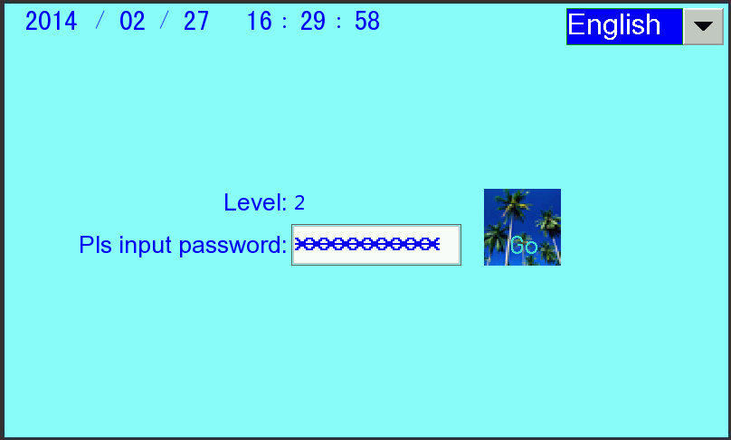

Chart 5.1.1

1.The top of screen displays the current time.
2.”English":is used to choose language.
3.Input password: Input different password to access the function interface,Level 1:181818, Level 2:282828.
- Level:Shows user's operating authority, higher level user has all the authority that lower level user have.
- Level 0 (no password):When turn on the machine shows level 0,access to “RUNNING” ,”MANUAL TEST” and “PRODUCTION RECORDS” interfaces to operate.
- Level 1:After user inputs password 181818,then shows level 1,user has access to “RUNNING”,”MANUAL TEST”,“PRODUCTION RECORDS”,”PROGRAM SETUP” and “SYSTEM SETUP”interfaces to operate.
- Level 2：After user inputs password 282828,then shows level 2,user has access to all the interfacs to operate.
Note: If some buttons can’t be operated after the user enters interface, then need higher level password to operate.
5.GO: Click to enter the main interface.

5.2 MAIN INTERFACE
In the user logging interface click“GO” to enter the main interface.As shown on Chart 5.2.1
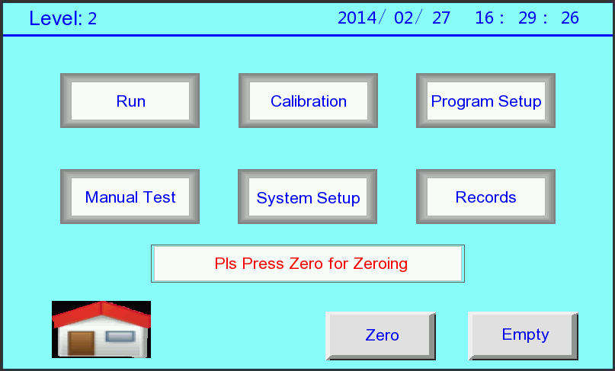

Chart 5.2.1
- The top of the screen successively shows the user logging password level,current date and time.
- Run：Click to enter automaticlly running interface.
- Calibration：Enter load cell calibration interface,only for Level 2 user.
- Program Setup:Enter program setup interface,only for Level 1 and Level 2 user.
- Manual Test：Enter manual test interface.
- System Setup：Enter system setup interface,only forLevel 1 and Level 2 user.

- Records：Click to enter Production records interface.
- ：User exits the main interface and return to the logging interface,then the user's password level is reset to level 0.
- Zero:Turn on the machine,an attention of “Pls Press Zero for Zeroing” will shows on the screen,which reminds you that you have not made manual Zero operation.Press “Zero” then all the weigh hoppers open and close after clean all the materials,and clean the float of load cell.The whole process the screen shows“Be In Zero,Please Waiting......”,it will automatically disappear after finishing zero.
- Empty：To clean the material in the uppper funne.Click “Empty”to enterempty interface.As shown in Chart 5.2.2.
- In empty interface, you can adjust the vibrator amplitude,input required amplitude value directly or press "+" "-" button to adjust.As Chart 5.2.3.
- At this time the machine being emptied and "Exit" button is hidden; After emptying the material, click "Empty" button again, the machine will stop empty, while "Exit" button is displayed, press the "Exit" button to return to the main interface.
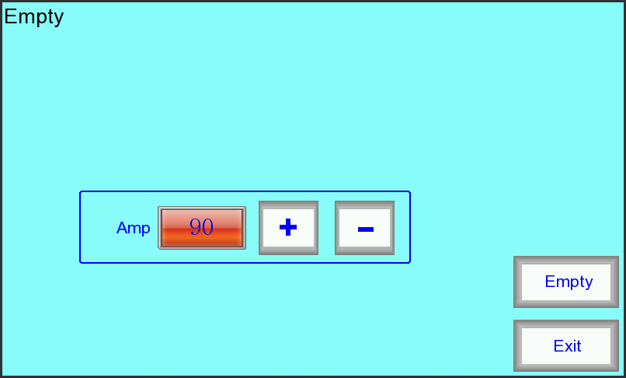

Chart 5.2.2.
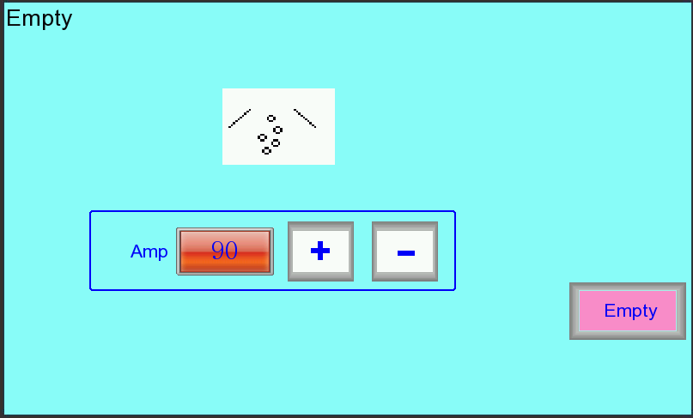

Chart5.2.3.

5.3RUNNING

5.3.1 RUNNING INTERFACE
On the main menu，press “Run”to enter running interface.As Chart 5.3.1.1
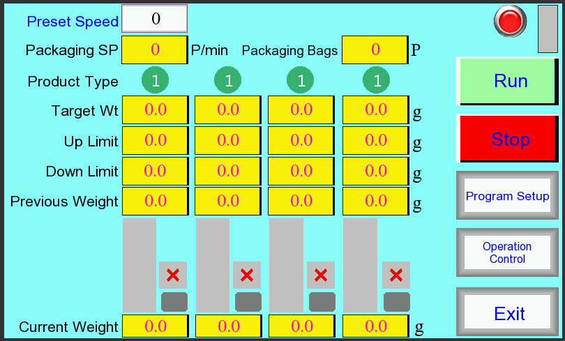

Chart 5.3.1.1
- Preset Speed：Setup weighing speed in unit time(minute) to limit minimun interval of each weighing.（0～99）
- Packaging SP：Count actual feeding speed every 10 seconds.
- Packaging Bags：Shows the number of finished packaging bags,when exit and leave the interface then form a production record store in the machine. Re-enter the interface the record will re-count.
- Product Type：Shows product type in each hopper,it’s used for mixing materials weighin.Details show in 5.6.1 PROGRAM SETTING（一）
- Target Wt：Shows the target weight of current program.
- Up Limit：Deviation over target weight.
- Down Limit：Deviation less target weight.
- Previous Weight：Shows the previous bag weight.
- Current Weight：Shows the current weight in weigh hopper.
- Feeding status bar graph:Display feeding status. Blue is feeding, green indicates the weight of weigh hopper within the qualified range, red is overweight; The color occupied area is the percentage of weight in weigh hopper compared to the target weight.
- Status display:The right area of each histogram display the status of each hopper, each character represents as below:
- D：The hopper is disabled；
- J：Feeding；
- R：Ready for weighing；
- T：Communication failure；
- Z：Auto zeroing in the running；
- √：The weight from weigh hopper to discharge chute gate is qualified;
- ×：The weight from weigh hopper to discharge chute gate is unqualified(overweigh).
- Run:Press “Run” and machine start running，in the mean time the operating status indicator changes from red to green.
- Stop：Press “stop” and machine stop running,in the mean time the operating status indicator changes to yellow.Press “run”again the machine running again.
- Material Detection Stick Figure: Display the material status of upper storage funnel.
- Program Setup: Press this button shows the window to modify parameter.As shown Chart 5.3.1.2
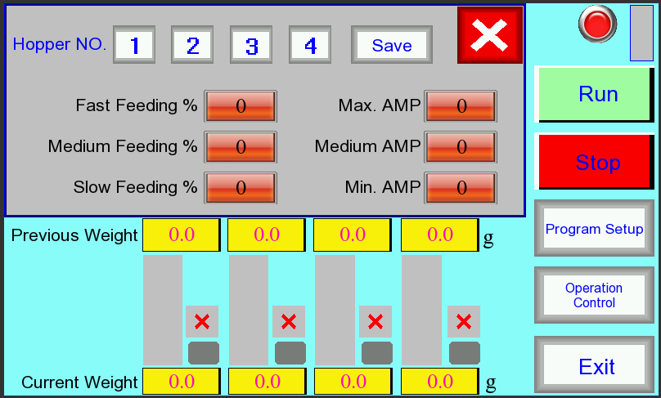

Chart 5.3.1.2
- Hopper NO.：Select the hopper No.to setup parameter,when selected will change to red.

- Save：After setup parameter,need to press “save” button that the parameter is effective.
- ：Close the parameter setup window.
- Other parameters setup details on 5.6.1 Program setup（一）
16.Exit：Exit running status and go back to main interface.

5.3.2 OPERATION CONTROL
In the running interface,Press“Operation Control” button to enter operation control interface.As chart 5.3.2.1.
1.Hopper selection:choose the hopper No.to control,when selected,the button frame turns green.
2.Weigh HP:Press this button then the selected hopper will run one time.
3.Run:Press “Run” button and machine runs.Oscilloscope element (grid area in the interface) will displays the current amplitude curve of the selected hopper (red), the flow curve (yellow) and the weight curve (blue), while the corresponding value of the display element also displays the current data, providing a basis for modifying the parameters.
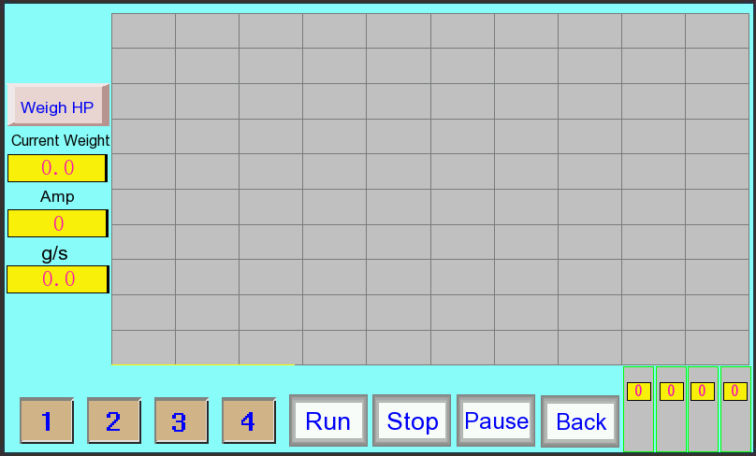

Chart 5.3.2.1
4.Stop:Press button and machine running.
5.Pause:Press button and machine pause running.
6.Histogram and status display: real-time displays operating status of each hopper feeding, details are on 5.3.1 RUNNING INTERFACE.
7.Back:Press and exit,go back to running interface.

5.4 PRODUCTION STATISTICS

5.4.1 PRODUCTION RECORD
On the main interface,press “Records” to enter production record interface,as shown in chart 5.4.4.1.
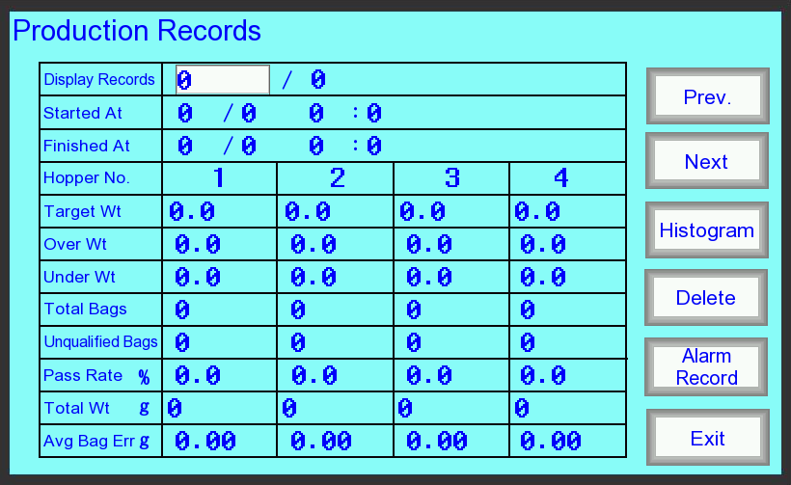
Chart 5.4.1.1

- Display Records：Current production record and total production records.Input hte record No. that you need(1-2000).
2.Start At.:Production record starting time.
3.Finished At.:Production record finishing time
4.Target weight:Target weight of production records
5.Up limit:Deviation over target weight
6.Down limit:Deviation less target weight.
7.Total Bags:Bags amount of each hopper in the records.
8.Unqualified bags:Unqualified bags of each hopper statistic from under Wt and over Wt.
9.Pass rate:It refers to the passing bags of each hopper according to under Wt and over Wt.of system setup.
10.Total Wt.:Total weight of each hopper in the records.
11.Average Bag Err:Average error of each hopper.
12.Prev.：To check last record.
13.Next：To check next record.
14.Delete:Delete all the production records(only input password level 2 can do it).Press “Delete”and will show a window to confirm this operation.As Chart 5.4.1.2
- Yes：Delete all the production records
- Cancel：without any operations and close this window.
- Histogram:Press to enter histogram interface.
- Alarm records:Press to enter alarm record interface.
- Exit:Exit production record interface and back to main interface.

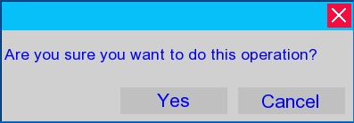

Chart 5.4.1.2

5.4.2 HISTOGRAM
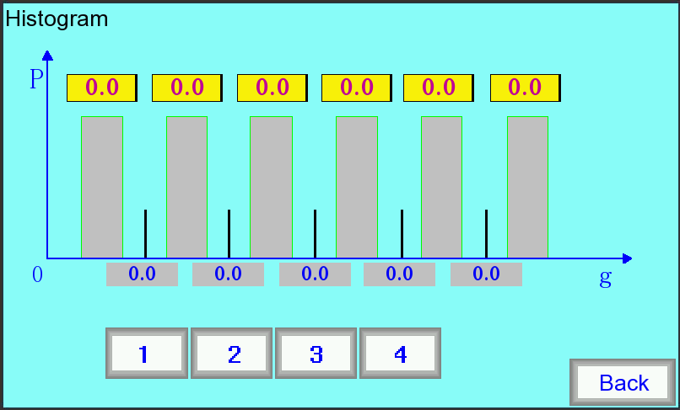
In production record interface,press “Histogram” to enter histogram interface.As Chart 5.4.2.1.

Chart 5.4.2.1.
1.Hopper selection:choose the hopper No.to control,when selected,the button frame turns red.
2.Coordinate:
①Abscissa with 5 values shows the weight division,the contents as followings:
1)Only setup Up limit without setting up under limit:
the 5 values on abscissa successively display:target weight、target weight+Up limit*1、target weight+Up limit*2、target weight+Up limit*3、target weight+Up limit*4.
2)Setup both Up limit and under limit:
the 5 values on abscissa successively display:target weight-under limit*1、target weight、target weight+Up limit*1、target weight+Up limit*2、target weight+Up limit*3.
②Ordinate shows the bags QTY of corresponding weight in percentage of total bags.
3.Back：Exit histogram interface and back to production record interface.

5.4.3 ALARM RECORD
In production record interface,press “Alarm Record” to enter alarm record interface.As Chart 5.4.3.1.
- Serial No.：Rocord NO. of alarm recors.
- No.：Device Address that alarm occurs.
- Failure Time：Time that alarm occurs.
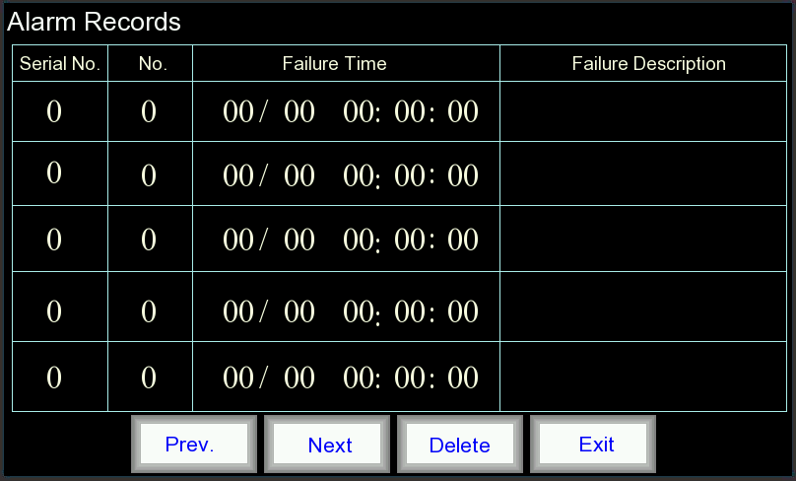

Chart 5.4.3.1
- Failure Description：The specific contents of failure, details as below:
Code | Alarm description | Initiation | Pic.
0 | No alarm | _ | No
7 | Load cell ADC alarm | Module | 
8 | Module AD transit failure | Module | 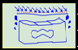
9 | Module CAN connection irregular | Mother board | 
10 | Mother board CAN bus irregular | Mother board | 
11 | Module reset alarm | Module | 
12 | Module software reset | Module | 
13 | No answer alarm when sending parameters | Mother board | 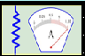
14 | Date length error alarm when sending parameters | Mother board | 
15 | Error alarm when sending parameters | Mother board | 

- Prev.：To check last alarm record.
- Next：To check the next alarm record.
- Delete:Delete all the production records.Press “Delete”and will show a window to confirm this operation.As Chart 5.4.3.2.
①Yes：Delete all the production records
②Cancel：without any operations and close this window.

Chart 5.4.3.2
- Exit：Exit alarm record interface and go back to production record interface.

5.5 MANAUL TEST

5.5.1 MANAUL TEST INTERFACE

Press’Manul Test’ in the main menu to enter the manul test interface,shown in chart 5.5.1.1.

1.Hopper selection：Press“Select All”，that all the hoppers are selected;if press“1”、“2”、“3”、“4” that is selected corresponding hopper.when hopper selected,the button frame turns green.
2.Amp：Setup vibration pan amplitude by manually (1~199), input required amplitude value directly or press "+" "-" button to adjust.(can Select the "Select All" button unified modified).
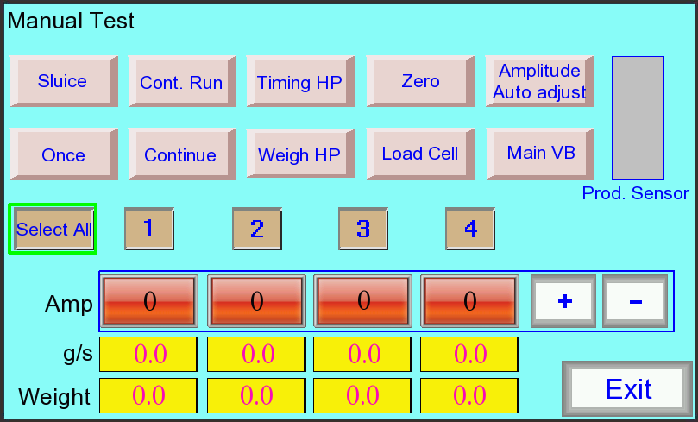

chart 5.5.1.1
- g/s: Flow, weight of material from VB pan fall to the weigh hopper for 1 second.
- Weight:Current weight in each hopper(notice:must press “load cell”button)
- Sluice:Press it,and select hopper No.(only for machine with sluice).then the sluice on linear vibration pan run one time,and “sluice” button frame turn red.Press again that the sluice close,the button turn to original.(Currently there are no sluices on 4 heads linear weigher).
- Once:Select hopper No. and press “Once”,the corresponding vibrator will vibrate according to the preset program for 1 second. For example: Press the button under No.1 hopper, the No.1 vibrator will vibrate with setup amplitude for 1 second.
- Continue: Press the button,the corresponding vibrator will vibrate continually according to the preset program,and the button turn red.This is a switch button,press one time to run,press again to stop.
- Weigh HP.:Press”Weigh HP” and selected hopper will run one time according to preset program.
- Cont.Run:Select one hopper and press “Cont.run”,corresponding vibration pan and hopper will continually run,and “Cont.run” button display “stop”mode,press”Cont.run” again to stop,and button recovery to “Cont.run” mode.
- Load cell:Press button and displays the current weight of selected hopper.
- Zero:Press button to clear the floating on selected hopper.(Empty weigh hopper before zeroing)
- Main VB:Press button and selected vibration pan will vibrate one time according to preset program.Related parameters:setup vibrator signal output port to 19,don’t setup main vibration pan feeding time to 0.(only for machine with vibrator on upper storage funnel)
- Prod.sensor:Test material in upper storage funnel.when there is no material,the mother board output feeding signal.Related parameters:"Level Fed Tm"和"No Prod. Pau. Dly".
- Amplitude auto adjust:Press button and go to amplitude auto adjust interface.
- Exit:Press”exit”and go back to main menu.

5.5.2 AMPLITUDE AUTO ADJUST
In maual test interface,press “Amplitude auto adjust” to enter amplitude auto adjust interface.As Chart 5.5.2.1.

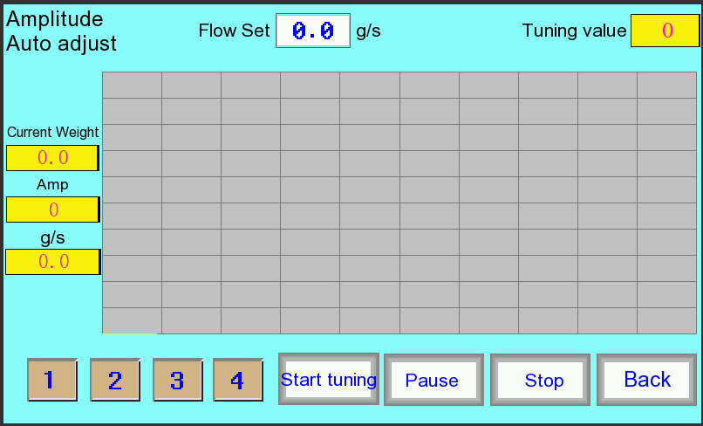

Chart 5.5.2.1

- Hopper selection：Press“1”、“2”、“3”、“4” that is selected corresponding hopper.when hopper selected,the button frame turns green.
- Flow Set：To setup desired flow value（0.1～999.9g/s）.
- Start tuning：Press“Start tuning”，the selected linear vibrator start feeding,the amplitude increase from 30,simultaneously it will shows the value of the current weight, amplitude and flow,when it reaches the preset value, "Tuning value" shows the adjusted amplitude as a reference.
- Pause：Pause auto adjust running.
- Stop：Pause auto adjust running.
- Back：Exit amplitude auto adjust interface and go back to manual test interface(amplitude auto adjust process is efffective only when machine is in stop running status.)

5.6 PROGRAM SETUP

5.6.1 PROGRAM SETUP1
On main interface,press “program setup” to enter PROGRAM SETTING 1.Shown in chart 5.6.1.1.
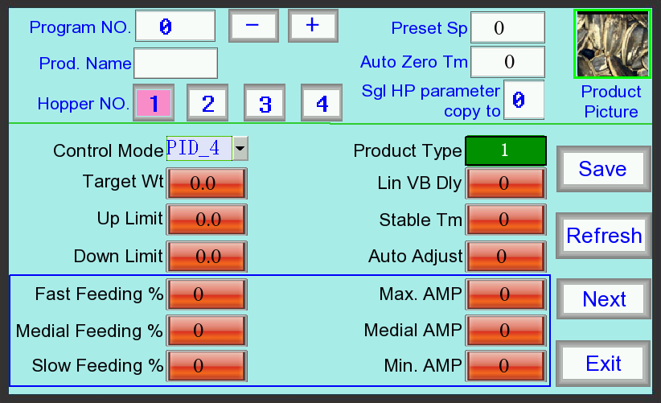
Chart 5.6.1.1.

There are two types programs in the program setup.One is for the whole machine,another is for single hopper.
Whole machine programs: the parameter is available to all the hoppers and other public parameters.
Single hopper programs: only available to the specific hopper parameters.

- Whole machine programs

- Program No.: The program No.of weighing products,total 20(1~20) for optional.Input number directly or press "+" "-" button to operate.
- Prod.Name:Name of products for different programs,maximum input six characters.
- Product picture:There are different pictures to choose so that to distinguish different program products.Click product picture and choose picture(as chart 5.6.1.2),After choosing,press “back” button to go back program setup interface.
- Preset Speed: Preset speed to prevent the system running too fast (1 to 99 bags/ min)



chart 5.6.1.2
- Single hopper programs
- Hopper No.:Hopper No.of each hopper of each program.when hopper selected,the button frame turns red(for 4 heads linear weigher can choose from “1~4”,for 2 heads linear weigher can choose from “1~2”).
- Single hopper parameter copy to:copy parameter of selected hopper to other hoppers(for 4 heads linear weigher can choose from “1~4”,for 2 heads linear weigher can choose from “1~2”).,input hopper No.directly and press “confirm”;Input 0 to copy to all hoppers,then all hoppers’ parameters are the same.
- Auto zero time:Interval time of each weigh hoper to auto zero,prevent to make load cell floating too much(1~99 minute).When zeroing,the interface will displays “Z” shows zeroing.
- Target Wt.:Setup target weight for product to be weighed.（For 4 heads linear weigher：2.0～3200.0 g；For 2 heads linear weigher：2.0～15000.0 g；For one head weigher：2.0～3200.0 g)
- Up limit:Deviation over target weight（0~99.9 g)
- Down limit.:Deviation less target weight（0~99.9 g)
- Product type:Product type of each hopper,it’s suitable for weighing mixing products.(for 4 heads linear weigher:1~4,for 2 heads linear weigher:1~2;for one head linear weigher:1)By setting up product type for each hopper to make machine with multi function(the following is in the example of small linear weigher,one head weigher is not with multi function):
①For weighing one product and meet the requirement of single hopper weight:setup the same value of product type for each hopper.
②For weighing one product and target weight is more than single hopper weight,then need more hoppers to reach target weight.For example,for 0.5L hopper 4 head weigher,the Max. Single hopper weight is 400g,but target weight is 800g,then we can make 2 hoppers to discharge product at the same time,the result is 800g for one bag.Product type parameter of hopper number 1~4 can setup as 1,1,2,2.
③For weighing mixing products:For example,0.5L hopper weigher to weigh 4 kinds of different products and discharge these 4 products in one bag,then we can setup product type of 1~4 hopper as 1,2,3,4(each hopper is different).
- Stable time:when feeding product up to “target weight-down limit” value,the vibrator will stop running,delay setting time,the product fully discharge from linear vibration pan to weigh hopper,then the machine read current weight as result（1~999*10ms,recommendation:80）
- Lin VB Delay:As begining from weigh hopper opening,linear vibrator runing according to setup linear vibraor delay time and feeding to weigh hopper,and begin next bag weighing,which is to prevent feeding when weigh hopper still opening（1~999*10ms,recommendation:30）
- Closing Weight Ratio：When gate part close,the weight of weighing hopper in percentage of target weight(0~99,recommendation:90).Linear vibrator start feeding,while the gate on vibration pan opening,making feeding products with the Max.flow.When hopper weight up to preset weight,the gate will close,then vibrator feeding make smaller,which is to make higher accuracy.(For 4 head weigher is not with gate parts).
- Control Mode：In the process of feeding for one time weighing,the machine control mode for linear vibrator amplitude.

chart 5.6.1.3

chart 5.6.1.4
There are PID3 and PID4 two control mode to choose,alternately switched by touching the display frame selection. PID3 mode divides feeding amplitude into three segments for a bag,while PID4 mode divides into four segments.

- In PID3 control mode，relations of feeding proportion,amplitude and material weight are as chart 5.6.1.3.The purple line is material weight curve,the red line is amplitude curve.
①When current weight is less than the weight setting in “Fast Feeding %”,the vibrator works with Max.amplitude and Max.flow,shown as T0~T1;
②When current weight between “Fast Feeding %” and “Slow Feeding %”,the vibrator amplitude moves from “Max.amp”towards to “Min amp”,the corresponding flow will slowly,shown as T1~T3.
③When current weight is more than “Slow Feeding %”but less than target weight,the vibrator works with Min.amplitude until up to target weight,shown as T3~T4.

- In PID4 control mode，relations of feeding proportion,amplitude and material weight are as chart 5.6.1.4.The purple line is material weight curve,the red line is amplitude curve.
①When current weight is less than the weight setting in “Fast Feeding %”,the vibrator works with Max.amplitude and Max.flow,shown as T0~T1;
②When current weight between “Fast Feeding %” and “Medium Feeding %”,the vibrator amplitude moves from “Max.amp”towards to “Midium feeding amp”,the corresponding flow will slowly,shown as T1~T2.
③When current weight between “Medium Feeding %” and “Slow Feeding %”,the vibrator amplitude moves from “Midium.amp”towards to “slow feeding amp”,the corresponding flow will slowly,shown as T2~T3.
④When current weight is more than “Slow Feeding %”but less than target weight,the vibrator works with Min.amplitude until up to target weight,shown as T3~T4.

- Fast Feeding %：Percentage of feeding is up to target weight with Max.Amp.(1-99,recommendation:50).
- Max. AMP:When feeding is up to target weight,the vibrator amplitude is maximum(1~199)
- Medium Feeding %：Percentage of feeding is up to target weight with medium amplitude(1~99),control mode is available for PID4.
- Medium AMP:Vibrator amplitude when feeding is up to “medial feeding”(1~199),control mode is available for PID4.
- Slow Feeding %：Percentage of feeding is up to target weight with Min. amplitude(1~99,recommendation:95)
- Min. AMP：When feeding is up to target weight,the vibrator amplitude is minimum (1~199)
- Auto Adjust:Automatically adjust amplitude interval,amplitude adjust within the up and down range (0 ~ 5,0: turn off ). Control mode is available for PID4.Details on 5.6.2 PROGRAM SETUP 2.
- Save: Press "Save" button to save the changed parameters, or it will not be saved anymore after power-off.
- Refresh:Press button to refresh parameters display.
- Next:Press “Next”switch to PROGRAM SETTING 2.
- Exit:Press “Exit” go back to main interface.

5.6.2 PROGRAM SETTING 2
In PROGRAM SETTING 1, press the "Next" button to enter the PROGRAM SETTING 2 interface.As Chart 5.6.2.1.
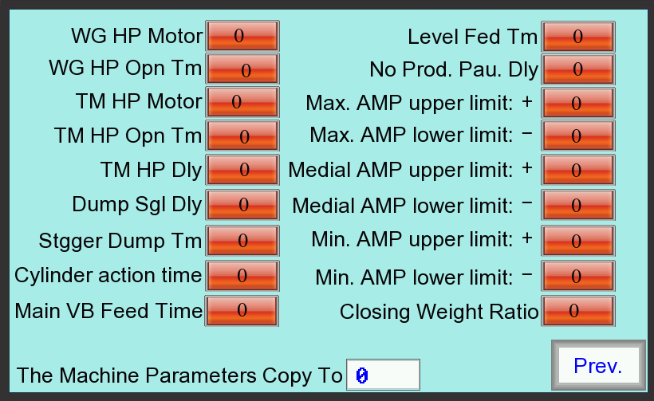
Chart 5.6.2.1.
- WG HP Motor:Weigh hopper motor mode setup（0~4）,details on 5.7.3 Motor mode.
- WG HP Opn Tm:After weighing hopper operation is completed, delay the weigh hopper open time and the hopper start to close,which ensure that the material is completely discharge from the weigh hopper (0 ~ 999 × 10ms, recommendation:1). This parameter is not available for big 2 heads linear weigher.
- Weigh HP Dly：When machine is with timing hopper,while timing hopper opening,delay weigh hopper open time,,after that weigh hopper discharge material to timing hopper,which prevent material discharge directly when timing hopper is opening.(0 ~ 999 × 10ms, recommendation:0）。
- TM HP Motor:Timing hopper motor mode setup（0~4）,this parameter is available when machine with motor timing hopper,details on 5.7.3 Motor mode.
- TM HP Opn Tm:When machine is with motor timing hopper,after timing hopper open operation is completed(When the machine is with cylinder timing hopper,counting time from timing hopper door open),delay timing hopper open time to ensure material fully discharge from timing hopper（0～999 ×10ms，motor timing hoppe recommendation:1;Cylinder timing hopper recommendation:50).
- TM HP Dly:Timing hopper delay:The delay time for the timing hopper to discharge product into the packaging machine after weigh hopper opens（0～999 ×10ms，recommendation：50）.
- Dump Sgl Dly:Dump signal delay:After dumping from weigher,delay the setting time to send dump signal to packaging machine（0～999 ×10ms）.
- Overwt Sgl Tm：In machine running,if previous bag is over weight,in the mean time when machine receives the discharge signalfrom packaging machine,it will also output over weight signal,this value is the output over weight signal time（0～999 ×10ms）.
- Stgger Dump TM:For weighing different materials,in order to prevent blocking in the discharge chute gate when mixing material discharge at the same time,so to setup stgger dump time to make the interval time between two discharge（0~300*10ms）
- Cylinder action time:When the machine is with cylinder drive weigh hopper,start counting from the moment weigh hopper door open, delay cylinder action time,and after this time begin to close weigh hopper to ensure that the material is completely discharge from the weigh hopper (0 ~ 300 × 10ms) . This parameter is only available for big 2 heads linear weigher.
- Main VB Feed Time:When machine is with vibrator,the time for the main vibrator vibrate one time（0～500 ×10ms）.Each hopper vibrator begins to vibrate and feeding that vibrator action one time.
- Level Fed Tm:After material photoelectric detection switch detects there is not enough
material,feeding signal continue output and will stop after preset level feeding time when detects enough material （0~99s）
13.No.Prot.Pau.Dly:The period time for the machine to stop when there are not enough products on the upper storage funnel.Until there are enough products the machine will auto run（0~99s）.When setup to 0 is to close this function,even if detects the material is enough the machine will always running.
- Max. AMP.Upper limit:Upper limit of Max amplitude auto adjust（0~10）
- Max. AMP.Lower limit:Lower limit of Max amplitude auto adjust（0~10）
- Medial AMP.Upper limit Upper limit of medial amplitude auto adjust（0~10）
- Medial AMP.Lower limit Lower limit of medial amplitude auto adjust（0~10）
- Min. AMP.Upper limit Upper limit of Min.amplitude auto adjust（0~10）
- Min. AMP.Lower limit Lower limit of Min.amplitude auto adjust（0~10）
- The machine parameters copy to:copy whole set parameters to other parameter No. （0-99）
- Prev.:Press “Prev.” to go back PROGARM SETTING 1.

5.7 SYSTEM SETUP

5.7.1 SYSTEM SETUP INTERFACE
In the main interface.press “System setup” to enter menu,as shown in chart 5.7.1.1:

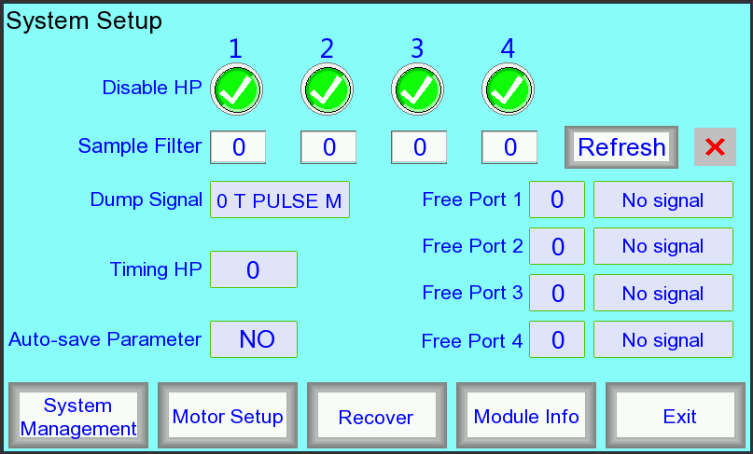

Chart 5.7.1.1

1.Disable Hp:“√”is available,“×”is disable.Touch the corresponding "√" or "×" button to alternately switch under the hopper number.
2.Sample Filter:setup sample filter for each hopper’s load cell（1～19，recommendation：5）.The bigger sample filter the higher accuracy and need more time to read the weight.When change sample filter value,input needed filter value directly and then in the right of “Refresh” will shows “√”.Press “Refresh” displays the current filter value.
3.Dump signal:The signal that the machine receives the dump signal from packaging machine,by touching button to switch alternately.
A. 0 T PULSE M:Before weighing machine is ready,it receives a "on to off" request signal,and after the machine is ready, the machine will discharge.
B. 1 T PULSE N:Only after weighing machine is ready, it receives a "on to off" request signal, then the machine will discharge.
C. 2 T VOLT M:Before weighing machine is ready it receives the request signal "ON" (even if “off” before weighing is ready).After weighing is ready, the machine will discharge.
D. 3 T VOLT N :After weighing machine is ready it receives the request signal "ON", and there is a process from "off" to "on" from previous bag request signal(for the first bag don’t need this process), after that the machine will discharge.
- Timing HP:The following are operation modes to select about the machine is with timing hopper or without timing hopper.
- 0：without timing hopper.
- 1：with timing hopper,available for connects with one packaging machine,both of the doors open at the same time.
- 2：with timing hopper,available for connects with two packaging machine,the door on left and right sides discharge respectively to each packaging machinel
- 3：with timing hopper,available for connects with two packaging machine.When the weight is qualified it will discharge from the left door,and if overweight it will discharge from the right door .

- Auto-save Parameter:”NO” is not auto-save,”YES” is auto-save.By touching button to switch alternately.
- Free Port:The machine is equipped with four free output ports, each port can freely select the output signal (0 to 25). Each free port has two display boxes.The number in the left box is signal function number,and the right box is the explanation text for the signal. When choose signal function number you can touch the left display box to input the number and the right box will show the text automatically; also available by multiple touching the right box to switch the signal function.When input the signal number which is no signal function then the right box will be automatically hidden.Setup free port output signal.as following shows:
Free port No. | Output signal | Free port No. | Output signal
0 | No signal | 1 | Discharge 1
2 | Discharge 2 | 3 | Ready
5 | Overweight | 7 | Feeding
8 | Running | 9 | Empty
10 | Alarm | 13 | Sluice 1
14 | Sluice 2 | 17 | Hopper 1
18 | Hopper 2 | 19 | Main VB
21 | Timing HP 1 | 22 | Timing HP 2
23 | Reserved 1 | 24 | Reserved 2
25 | Reserved 3

- Recover：Click“Recover”，a confirmation window comes out.As shown on Chart 5.7.1.2.

Chart 5.7.1.2

- Yes：Make all the parameters recover to the original data (such as motor mode, free port setup,the program number from 1 ~13 parameter , etc.).
- Cancel：Close the window and don’t do any operations.
- System Management：Press button and go to the system management interface.
- Motor Setup：Press button and go to the motor setup interface.
- Module Info：Press button and go to the module information interface.
- Exit：Exit system setup interface and go back to main interface.

5.7.2 SYSTEM MANAGERMENT
In system setup interface,press“System Management”button to enter managerment interface.As shown on Chart 5.7.2.1
- Level 1：Input new 6 number to change password.
- Level 2：Input new 6 number to change password.
- BACKLGHT：Back light time,The time for the LCD to be in a poor light due to no operation .Range:1~99min.Input 0 is to close this function.
- Time Setting：To setup time of hour,minute and second for the system.
- Date Setting：To setup date of month,date and year for the system.
- Screen Version：Display the version No.of the touch screen program.
- CPU Version：After connecting with CPU will display the version No.of CPU software.

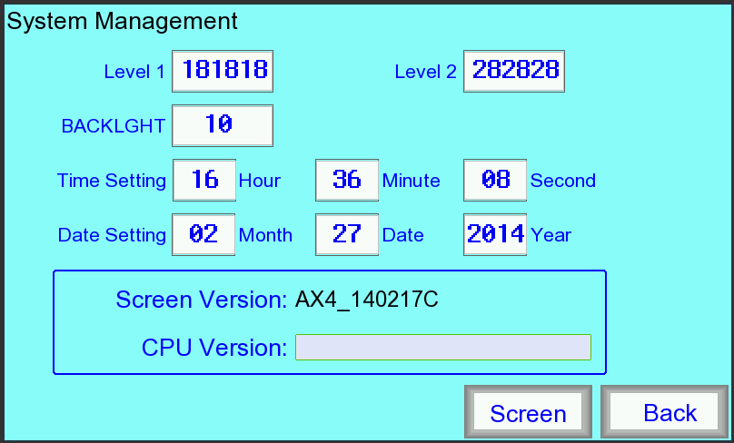

Chart 5.7.2.1
8.Screen：Press “Screen” to enter touch screen calibration function,click screen according to notices.After finishing calibration will auto go back to the menu,if failure,it will continue calibrating,if want to exit calibration,it need to take off power and turn on machine again.
9.Back：Press”Back” to go back SYSTEM SETUP interface。

5.7.3 MOTOR SETUP
In system interface,press“Motor Setup” to enter motor setup interface.As shown on Chart 5.7.3.1.

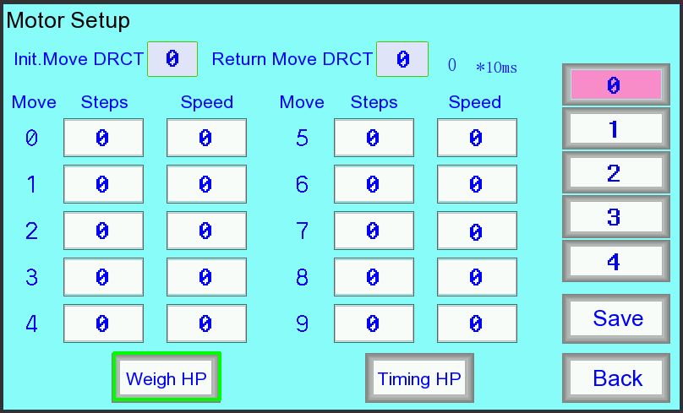

图5.7.3.1
- Select the object:Press“Weigh HP”or“Timing HP”（cylinder timing hopper no need to setup parameter) to see the object,when selected the button frame will turn green.
- Motor Setup：There are 5 modes(0-4) parameter for weigh hopper and timing hopper to select,when selected the button will turn red.The motor mode speed is successively increase from 0-4.
- Init.Move DRCT：The motor action direction of weigh hopper(timing hopper) opening,click “Init.Move Drct” the value switch between 0 and 1,”1” is anticlockwise rotary,”0” is clockwise rotary.
- Return Move DRCT：The motor action direction of weigh hopper(timing hopper) closing,click “Init.Move Drct” the value switch between 0 and 1,”1” is anticlockwise rotary,”0” is clockwise rotary.
- Move：Action one time for the hopper motor is to be divided into 10 segments,0-4 is for opening action,5-9 is for closing action.
- Steps：Each segment angle of motor running(1-100),Init.Move DRCT must be equal to Return Move DRCT and both of these more than 50 steps.
7. Speed：Each segment speed for motor running.（30～255）。
8.Save：Press "Save" button to save the changed parameters, or it will not be saved anymore after power-off.Press“Save” and comes out a window to confirm the operation.As shown on Chart 5.7.3.2.
- Yes：Press “yes” to save the new motor setup parameter.
- Cancel：Press “Cancel” to give up saving and close the window.
9.Back：Exit the motor setup interface and back to system setup interface.

Chart 5.7.3.2

5.7.4 MODULE INFO
In system setup interface,press“Module Info”button to enter module information interface.As shown on Chart 5.7.4.1.

- Version In.：Press to check the version information.
- Position Che. In.：Press to check weigh hopper motor position information.“0”is for motor in running position；“1”is for motor in stop position.
- Back：Exit the module information interface and back to system setup interface.

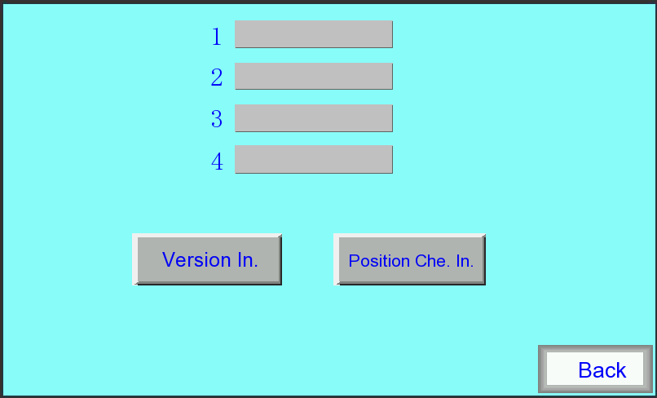

Chart 5.7.4.1

5.8 SENSOR CALIBRATION
In main interface,press “Calibration” to enter calibration menu:as shown in chart 5.8.1:

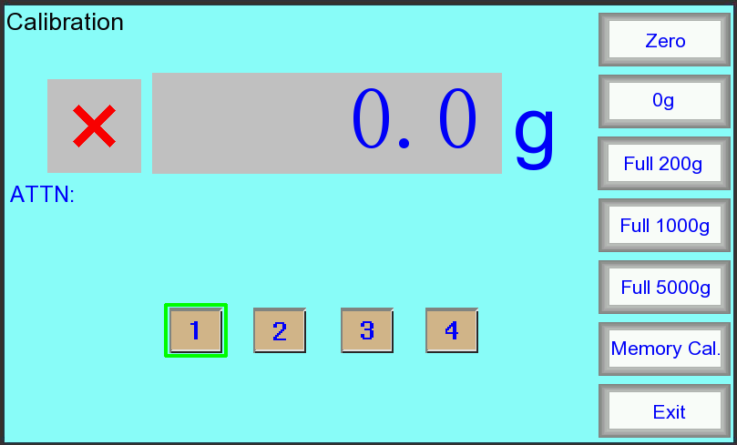

chart 5.8.1

- Preparations before calibration :prepare for calibration standard weight for corresponding machine(for 0.5L hopper 4heads weigher：200g；for big 2 heads weigher：5000g；for other machines：1000g），and enter manual test interface to empty material.
- Hopper selection:After finishing the above preparation,enter sensor calibration interface,there will be a notice “Enter Weigh Hopper No.”.Then you can touch the hopper NO.that need to calibrate,when selected,the button frame will turn green,if module is normal connection,the“×”will shows as “√”.
- 0g：After selecting hopper No.press“0g” button，there is a notice“Calibrating…”，after a few seconds the machine notices“Zero Success √”；if 0g calibrating is not successful,the machine will show"Zero Failed ×" that need to make a re-calibration.
- Full：After 0g calibration is ok,machine has a notice that“Put 200g/1000g/5000g weight into Weigh HP and press Full”，then we should put a suitable weight in weigh hopper(0.5L hopper 4 heads weigher：200g；big 2 heads weigher：5000g；other machines：1000g），after that press the button(0.5L hopper 4 heads weigher："Full 200g"；big 2 heads weigher："Full 5000g"；other machines："Full 1000"g），the machine will shows“Calibrating…”，after a few seconds the machine notices“Full Cal. Success √”；if full calibrating is not successful,the machine will show“Full Cal. Failed ×”，then need to make 0g calibration again.
- Testing:After notice“Full Cal. Success √”the machien reads the weight.Put a smaller weight(1/2 of calibrating weight) on weigh hopper,the display weight should be the same or very close to the weight on weigh hopper.If the display weight and weight on weigh hopper is more than 0.4g,,it should repeat the above steps to calibrate again.
- Memory Cal.：The previous successful calibration parameter data applied to the current calibration,the machine displays“Memo Cal. Success √”or“Memo Cal. Failed ×”.
- When shows one of the attentions of “zero failed” “Full Cal.failed” “Memory Cal.failed”,please check according to《Service manual》 to calibrate again.

NOTICE:The whole calibration process must be operated with no-wind、no-vibration environment by professional engineer.

6. MAINTENANCE AND REPAIR

6.1 MAINTENANCE
To ensure the normal operation, extend the usage life and to exert the economic value, the daily maintenance should be well performed.

1.How to maintenance
- Check before using the machine if any unrelated products on weigh hopper, and clean out dusty on the hanger after using.
- Check if there is abnormal sound of the motor and the machine in running process.
- The parts contacted with products, such as main vibrator pan, liner vibrator pan, feed hopper, weigh hopper, etc, which should be cleaned after daily use.
- Lubricate the joints of each hopper with edible oil every 7 days.
- Clean the dust outside of the machine every 1 months.

2.Notes
- The machine must be powered off before being cleaned.
- Don’t clean the displayer with alcohol.

6.2 REPAIR
The machine must be powered off during maintenance and inspection, and should be operated by trained technician.

6.3 FAULT DIAGNOSIS
FAULT | REASON | METHOD
1.No response of touch screen after power on. | 1.No DC24V power, DC1 switching power supply is damaged or line failure  2.touch screen damage | 1.Replace the switching power supply or check the line  2.Replace Touch Screen
2.Touch screen shows no connection | 1.No software  2.Communication line connection error  3.Motherboard without DC9V power, DC1 switching power supply is damaged  4.Bad communication lines  5.other reasons | 1.Turn the power off, turn on again after 10 seconds  2.Reconnect the communication lines  3.Replace the switching power supply  4.Replace the communication lines  5 Please contact our company.
3.Linear vibrator doesn’t work | 1.Module board is without AC110V power, TC1 transformer or QF1, QF2 breaker damage.  2.Module board is with AC110V power but vibrator amplitude parameter setting is too small  3.linear vibrator damage  4.Module board damage | 1.Replace the corresponding electrical components  2.Reset the amplitude values  3.Replace the linear vibrator  4.Please contact our Company
4. Weigh hopper is no action(except big 2 head weigher) | 1.Module board is without AC24V power,TC1 transformer or circuit breaker QF1 damaged or broken fuse FU2  2.Module board is with AC24V power, weigh hopper motor damage  3.Module board is damaged | 1.Replace the corresponding electrical components  2.Replace the motor  3.Please contact our Company
5. Weigh hopper is no action(only for big 2 head weigher) | 1.Pressure is inadequate  2.Fuse is broken  3.Solenoid valve coil damage or other fault.  4.Throttle adjustment is too small  5.cylinder failure  6. "Cylinder operation time" parameter is set too small. | 1.Connect a suitable gas  2.Replace the fuse  3.Replace the solenoid valve or coil  4.Adjust the throttle  5.Replace the cylinder  6. reset "cylinder operation time" parameter
6.Gate components does not operate (for machine with the gates parts ) | 1.Pressure is inadequate  2.Fuse is broken  3.Solenoid valve coil damage or other fault.  4.Throttle adjustment is too small  5.cylinder failure  6."Closing weight ratio" parameter is set too small | 1.Connect a suitable gas  2.Replace the fuse  3.Replace the solenoid valve or coil  4.Adjust the throttle  5.Replace the cylinder  6.reset "Closing weight ratio" parameter
7.Weighing is inaccurate | 1.Sensor don’t calibrating well  2.Weighing hopper is not properly installed,  3.There is something hanging on the weigh hopper  4.Parameter is setting unreasonable  5.Other reasons | 1.Re-calibration the sensor  2.Properly install weigh hopper  3.Empty the material  4.Reset parameters  5.Please contact our company
8.Nonstop feeding or don’t feeding | 1.Materials detect electric eye is damaged.  2.Motherboard OUT4 output I / O point has been turned on or off. | 1.Replace materials detect electric eye  2.Please contact our company
9.Other faults |  | 1.Operate according to manual instruction.  2.Please contact our company

7. TRANSPORTATION & STORAGE
1. Transport, install and disassemble the vibrators carefully. No throwing, bumping or reversing. Prevent from strong vibration and raining.
2. Vibrator should be kept in ventilated room with temperature range of -10℃~50℃, humidity no more than 80%, and without corrosive gases in the room.

8. OPEN AND CHECK
1. To avoid damage to the machine surface as opening the crate, the top cover board should be removed firstly, then to remove the siding wooden boards.
2. Check if the following documents are delivered with the machine：
①Instruction manual;
②Spare parts List;
3.Check the machine and spare parts as described in the spare parts list.

9. ELECTRIC CIRCUIT DIAGRAM
